PROGRAM – 9

AIM: Write a program to find page fault for a given string of pages.Assume the memory frames is an array of size n. Use LRU algorithm with counters or stack. What is the effect of increasing the number of memory frames?

INTRODUCTION: A page fault occurs when a program attemts to access data or code that is in its address space, but is not currently located in the system RAM. In the following program we use the LRU page replacement algo to find out the number of hits and misses. In this algorithm, operating system keeps track of all the pages in the memory in a queue, oldest page is in the front of the queue. When a page needs to be replaced ,page which is least recently used in the queue is selected for removal.

C PROGRAM : #include <bits/stdc++.h>
#define MAX 100
using namespace std;

int searchvector(vector<int> v,int item){

for (int i = 0; i < v.size(); ++i)
{
if (item == v[i]){
return 1;
}
}
return 0;
}

int extract_min(int arr[],int sz){
int min = arr[0];
int min_i = 0;

for (int i = 1; i < sz; ++i){
if (min>arr[i]){
min = arr[i];
min_i = i;
}
}
return min_i;
}

int main(){
int lru , hits = 0 , miss = 0 ;
// int pages[] = {7, 0, 1, 2, 0, 3, 0, 4, 2, 3, 0, 3, 2};
// int pages[] = {1, 2, 3, 4, 1, 2, 5, 1, 2, 3, 4, 5};
//int n = sizeof(pages)/sizeof(int);
int n;
int f_no = 4;

cout<<"\nEnter no. of pages : ";
cin>>n;
int pages[n];
cout<<"\nEnter string of pages: ";
for (int i = 0; i < n; ++i){
cin>>pages[i];
}
getchar();

cout<<"\nEnter the no. of frames: ";
cin>>f_no;

int indexes[n];
for (int i = 0; i < n; ++i){
indexes[i] = MAX;
}
vector<int> frames;

for (int i = 0; i < n; ++i){
int p = pages[i];
if(searchvector(frames,p)){
hits++;
}else{
if (frames.size() >= f_no){
lru = extract_min(indexes ,sizeof(indexes)/sizeof(int)
); frames.erase(
remove(frames.begin(),frames.end(),lru),
frames.end()
);
indexes[lru] = MAX;
}
frames.push_back(p);
miss++;
}
indexes[pages[i]] = i;
}

cout<<"\nhits = "<<hits;
cout<<"\nmiss = "<<miss<<endl;

}

OUTPUT:
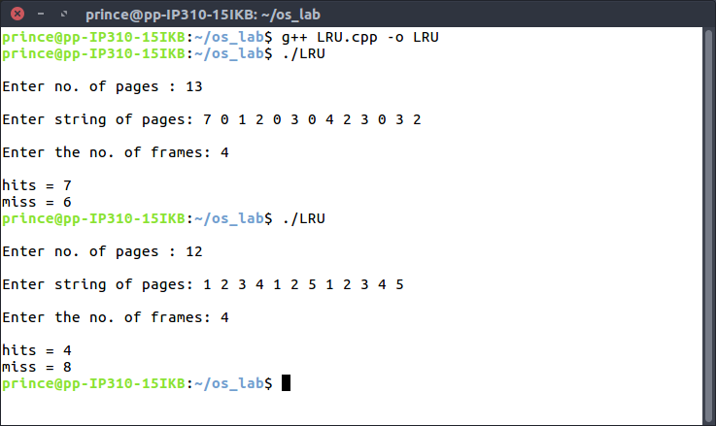
LEARNING OUTCOMES: From this program, we learnt the concept of Page Faults and how through the LRU page replacement algorithm, we can measure the number of Page Faults. Also, we observe that on increasing the number of frames, the number of page faults decreases.

